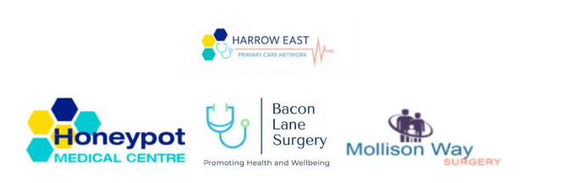
Harrow East Primary Care Network
Access Plan Achievements 2025/2026
Our Vision
We want to make sure that every patient in Harrow East can get high-quality, timely and appropriate care through their GP practice. Our aim is for patients to:
- See the right clinician, in the right place, first time
- Have continuity of care: seeing familiar faces who know their medical history and understand where this matters
- Receive fair and equitable healthcare, regardless of background or circumstance
- Feel informed and empowered to look after their own health
- Feel confident and supported in using digital health tools
Who We Are
We are Harrow East Primary Care Network (PCN): a group of three local GP practices working together to support over 41,000 patients in Harrow East:
- Honeypot Medical Centre (HMC)
- Bacon Lane Surgery (BLS)
- Mollison Way Surgery (MWS)
By working as one team, we can offer more services, faster access, and better support for all of our patients.
A) Telephone Access 2025/26
What we set out to do
- Answer 90% of patient calls within 10 minutes, across all three practices
What we did
- We installed cloud-based telephone systems at all three practices.
- We monitored call answering statistics daily, including hour by hour response rates throughout the day and week, to identify peak call times and times of the day/week with long waits to be answered.
- We arranged additional staffing at peak time to ensure timely call answering.
How we got on
- We improved steadily throughout the year
- We performed well during most of the months, and finished the year strongly:
- November: 81% calls answered within 1 minute; 90% calls within 10 minutes
- December: 82% calls answered within 1 minute; 92% within 10 minutes
- February: 71% calls answered within 1 minute; 90% within 10 minutes
- There was variation between our 3 practices, which affected the overall PCN average call answering rate.
- We have worked with and supported practices with lower call answering rates.
- We are proud of the progress we made and will continue to improve our services
B) Online Consultations 2025/26
What we set out to do
- Complete 90% of online consultation requests by the end of the next working day
- Each practice uses a different online platform:
- Honeypot Medical Centre: PATCHS
- Bacon Lane Surgery: AccuRx
- Mollison Way Surgery: DrIQ
How we got on
- Every practice exceeded the 90% target every single month
- Completion rates across the PCN stayed consistently above 95%
- All three practices regularly reached 99-100% completion
- Online requests were actioned reliably and promptly all year round

Thank you to all our patients who use our online services - it genuinely helps us reach more people more efficiently and responsively.

C) Named Care Teams (Continuity of Care) 2025/26
What we set out to do
- Provide a named care team to at least 2% of our patient population, with specific health and care needs who would benefit from continuity of care
- Each named care team consists of a GP and two other healthcare professionals (such as a nurse, pharmacist or care coordinator)
How we got on
- We identified the patients who benefit most from continuity of care, such as those with:
- Multiple long-term conditions
- Frailty
- Complex or ongoing needs
- Each patient was assigned a named team and personally told who would be looking after them
- These patients are offered an appointment with a consistent, familiar team that knows their history and needs
- Feedback shows this has made a real difference to patients’ experience and access to care
- We plan to expand this approach so more patients can benefit in future

D) NHS App Uptake 2025/26
What we set out to do
- Increase NHS App registrations by at least 10% compared to March 2025
What we did
- NHS App Ambassadors were trained and appointed to support patients with the NHS App
- Regular digital drop-in sessions were conducted by our NHS App Ambassadors and our patient champions, where patients were guided on an individual basis regarding accessing their NHS App
- We continue to promote the NHS App to our patients through reminders via phone calls, emails, displaying information about the App on our digital screens and the websites and our NHS App ambassadors and patient champions continue to run digital drop-in sessions.
How we got on
- In March 2025, we had 18,375 registered NHS App users across our three practices
- By March 2026, that had grown to 22,623 users
- New registrations were steady every month, with especially strong uptake in October and February

E) Patient Survey 2025/26
Why we did this
- We carry out patient surveys every year to hear directly from you about your experience of our practices and the care and service we offer
- We want to understand what is working well and where we can do better
- Survey results shape our priorities for the year ahead and help us to provide responsive care based on your needs
What we did
- We sent our patient survey to almost 27000 patients across the PCN and we are delighted that 7% of our patients responded to the survey.
Highlights of our survey:
A) Most patients reported that they are satisfied with the ways they can contact the practices
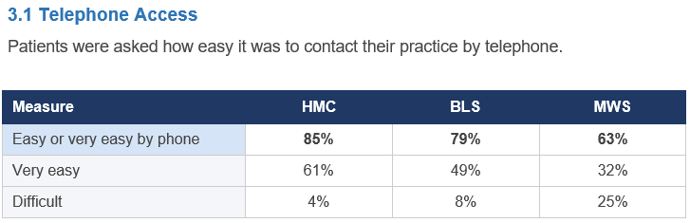

B) Patients were happy that they can get same day and routine appointments with their practices. There was variation among the three practices, but overall, most patients agree that routine appointments are easily available.

C) Patients reported that they are satisfied with using the NHS App, which has resulted in a consistently high usage across the 3 practices, and as a PCN, a significant number of patients have adopted the App over the year.
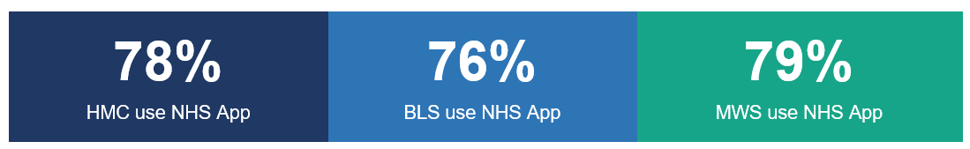
D) One of the most significant findings of the survey concerned the use of GP appointments to resolve queries that should have been managed by hospital services.
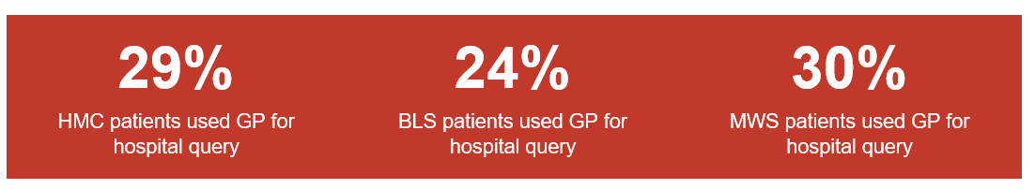
These appointments could have been available for patients needing healthcare from their GP and instead were being used on hospital related administrative queries. This is a significant interface problem, and one that we are raising with our ICB.

F) Patient Engagement Event 2025/26
What we did
The survey findings were presented to patients at a dedicated Patient Engagement Event held on 9th March 2026 at Canons High School. The event was designed to go beyond a one-way presentation of data, creating genuine two-way dialogue between the PCN and its patients.
We are delighted that over 200 enthusiastic patients across the 3 practices were present at the event and we are grateful to have had the opportunity for the face-to-face interaction and engaging discussions that ensued with all the groups of patients and carers at the event.
What we covered
- Welcome and introduction by our PCN Clinical Director, Dr Meena Thakur MBE.
- Contextual presentation on the pressures facing general practice nationally and locally, including the shift of workload from secondary to primary care.
- Presentation of the full survey results, broken down by practice, delivered by our PCN Clinical Director - see attached presentation
- Discussion segments after each major theme, inviting patient questions and comments.
- Facilitated breakout sessions organised around specific topics (access to practices – telephone/online/appointments), digital tools, Pharmacy First, hospital interface, self-management).
- Plenary, including feedback from breakout group-discussions
- Close, with the PCN committing to share actions publicly.
What patients told us
- Patients value face-to-face contact with their care teams
- Patients want clearer information about how to use online tools
- Patients welcomed the named care team approach, especially those with long-term conditions

Our Commitment to You
We want to make accessing care simpler, faster and fairer while making sure you see the right professional first time and feel empowered to look after your own and your family’s health.
Whether you need urgent help, routine care, ongoing support for a long-term condition, or guidance to stay well, we are working to care for you.
Hence, we have incorporated the feedback we received, both from our access survey as well as the engagement event in developing the Access Plan for the current year 2026/2027, presented below.

Photos from our Patient Engagement Event held at Canons High School on 9th March 2026

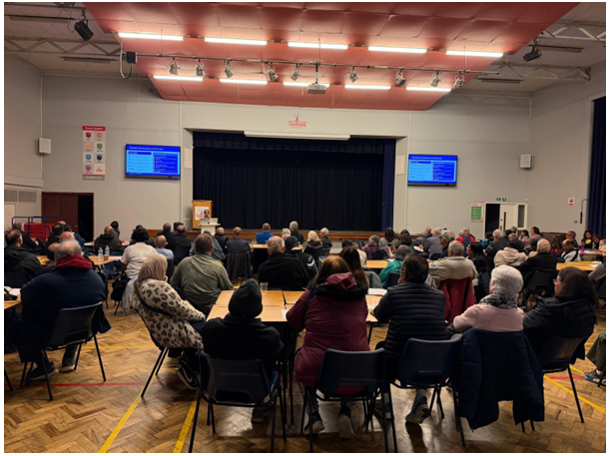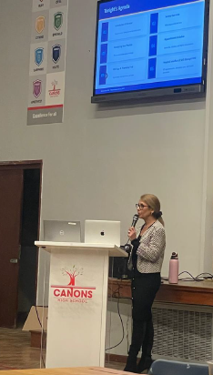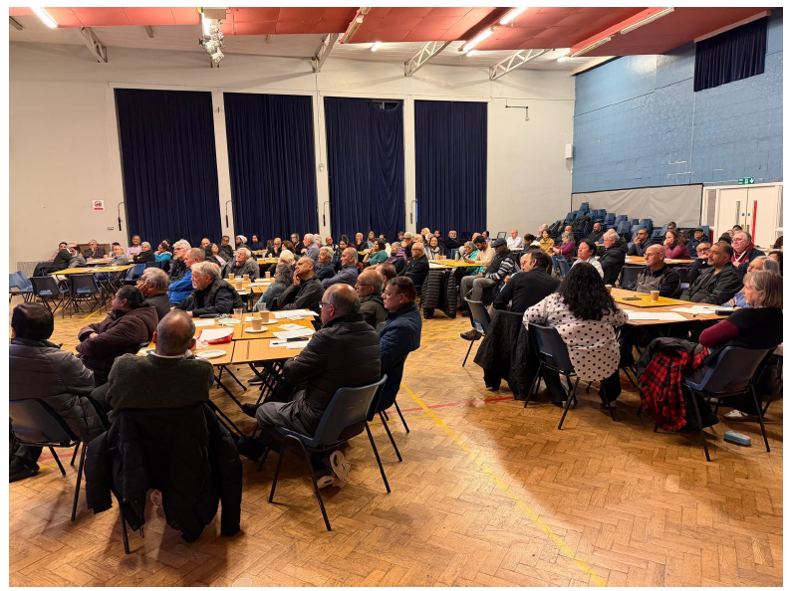

Access Plan 2026/27
Building on our achievements from 2025/26, the PCN and our practices continues to improve and expand our services to include more patient events, appointment availabilities, and digital support sessions, while also incorporating patients’ suggestions and feedback on how they best want to access their GP practices.

Our Access Plan for 2026/27 involves the following:
1) Contacting your practice:
We will continue to ensure that 90% of calls are answered by the reception team within 10 minutes of queuing at all 3 practices. We also aim to answer all calls within 15 minutes of queueing. Our practices will continue to monitor closely the online forms patients submit and triage them accordingly as soon as possible to ensure your requests are managed promptly and effectively.
2) 111/ UTC Slots at our practices:
As required by our ICB, our practices have ensured that we have appointment slots available in our practices daily, which can be used by the NHS 111 and Northwick Park Hospital Urgent Care Centre, where if a patient contacts NHS 111 or Urgent care centre with an urgent concern, they may book the patient directly into an appointment slot at our practices, if they feel your problem may be better addressed by your GP practice.
3) Continuity of Care:
We are expanding our continuity of care provision from 2% to 3% of our population, where we will continue to monitor and identify more patients with various long-term conditions, or have specific requirements, to have a named GP and care team and will inform them about their named team. This will help more patients to get appointments with their familiar team. We also plan to review these patients over the year to monitor the benefits of having a named team in place.
4) NHS App Registrations:
The NHS App offers many useful functionalities for ex: checking records, test results, order repeat medications etc, which we want all our patients to be aware of and use the NHS App for the convenience and ease of access. To do so, we have trained and appointment more NHS App Ambassadors for each of our practice as well as the PCN, who will be working closely with patients to get the App set up and support them with any other functions of the NHS App through digital drop-in sessions (either face to face in the practice/ over telephone).
The NHS Ambassadors are as follows:
Sl. No. | Name | Practice / PCN
1 | Yohansa Welikala | Honeypot Medical Centre
2 | Abdelmajid Bezzari | Honeypot Medical Centre
3 | Zahra Dattoo | Bacon Lane Surgery
4 | Sanjay Patel | Bacon Lane Surgery
5 | Clyde Rocha | Mollison Way Surgery
6 | Luke Constable | Harrow East PCN

5) Engagement Events & Survey:
We plan to further increase our engagement with our patients and local community groups over the coming year. We will plan to deliver various events which may include parent and patient workshops, informative and education sessions, working with community and faith groups and other patient engagement events.
We also plan to send out our annual Access Survey later this year to our patients and hoping to hear from you about your experiences with your practices and use your feedback to continue to shape and improve access to your practices and the services we offer.

